Group Project#1 - Interview Protocol

TASKS (By Thursday Night):

1. 2 pictures each (this can be visual representation or photo)
2. 2-3 pg summary of your interview. (who was it, why you chose them, where did you observe them, what did they say)
3. Top 3 themes from your discussions
4. Don’t we have to turn in a separate outline of our interview protocol questions? If we do Grace that would be perfect if you could finish that!

**The Interviews**

During Grace’s first interview, she spoke with one on her roommates who Grace says is always the first one ready. Whenever they go out as a group, she is the one who is impatiently waiting by the door, asking how much longer everyone will take, with a large sigh. Through asking her our series of questions, Grace found it difficult to pull the answers out of her. As she interviewed her in their living room, a casual setting, in Grace’s and her roommates’ own home, she expected them both to be comfortable, but at times they were not. For some reason asking people about their personal routine of getting dressed and picking out fashion may be a bit awkward. Everyone we know does this every day, but for some reason when questioned about this process, some find it difficult to describe a seemingly mundane and uneventful process. Grace felt that this roommate, being a middle class, female college student in her early twenties, who is an avid exerciser, would have an interesting take on juggling her professional and active lifestyle.

When Grace asked what her getting ready process looked like, she approached the question in a very systematic manner. When asking how she got dressed in the morning, a simple “from the bottom up” is all she had to work with. After a few more minutes of prying Grace dug deep to find the information that we wanted and needed to hear. This person usually picks out bottoms first, then goes from there. Maybe a pair of jeans, or a skirt. What top matches the skirt? What jewelry matches the top? This puzzle builds and the final outcome is a compilation of trial and error. During the interview, Grace’s roommate did state that she likes to have freedom when dressing, because she works at a job with a dress code. So, when given the chance to express herself through clothing, she is excited to do so. When asked the question “how important is style to you?” she answered, “not as important as comfort.” This was an interesting response, she claims that in her own wardrobe, if she isn’t comfortable and able to move easily, then it’s not worth her wearing. Then, Grace asked, “if you had an ideal wardrobe, what would it be and what’s stopping you from obtaining it?” She replied, excitedly, that yes she would love to buy name brands (especially for workout gear) such as Nike, Lulu Lemon, North Face, etc., but she simply can’t afford these styles.

For Grace’s other interview she talked with a different roommate, still a young professional female in her mid-20s. This particular person is in a transition from college kid lifestyle to blossoming career woman. Her style has most definitely been reflected in her life’s changes. As Grace lives with her every day, she has noticed her dress becoming more “mature.” Grace conducted this interview in her room, as they went through her closet together. Since they are very close friends this became a casual conversation, with it being hard for them to stay on track. But, in this type of setting Grace was able to pick up on some very important “ques”.

“I think I’m going to throw out all of my crop tops after I graduate.” she said. When asked why, she claimed she felt that they were too “young” and screamed college kid. Grace then proceeded to inquire how she forms these opinions on style, and why she feels certain items aren’t acceptable for her to wear anymore. This roommate claims that style is a first impression, and that fashion is a reflection of a person. But then, an interesting argument arose: is that shallow? One thing that should be brought to our attention during this process is that we are not to promote validity through appearance. Grace and this roommate both agreed that there is a fine line between helping someone’s day get easier, and making them feel more confident about what they wear, to shaming their personal expression.

The second set of people interviewed were two of Kristen’s very close friends that both live back in her hometown. She specifically chose to interview both of them because they are polar opposites in how they shop, pick out their outfits, how often they go out, and how long it takes them to get dressed before going out anywhere. The first interviewee was Olivia who is currently 22 and employed as a sales associate at an upscale store at the Somerset Collection mall in Troy, Michigan. She also works for a designer store named St. John. A brief synopsis on her is that in her free time she frequently attends many parties and events for her sorority that she is in. Olivia also has dedicated weeknights to going out with her friends every week for dinner and drinks. She also lives at home with her parents currently studying journalism and has four other siblings. Olivia is also very passionate about the clothes she wears and her style, and one last detail about Olivia is that there have only been two jobs she has had in her entire working life that *weren’t* clothing stores.

When Kristen chose to interview Olivia she knew it was going to be a little tricky since Olivia lives about an hour and a half away from Michigan State University. Knowing that she was one of the perfect candidates for her to interview out of anyone else she knew, Kristen didn’t let that hold us back from gathering the data we needed from her. Via e-mail, Kristen sent her an attachment of the questions we wanted her to answer. After we read through her answers, we knew we wouldn’t have been able to collect the raw, “in-the-moment”, observations with Olivia’s answers this way. However, it actually raised an opportunity for us to receive more detailed and descriptive answers since the method Kristen chose gave both of these interviewees more time to gather their thoughts and perfect all the details they wanted to include in their responses. Upon reading through Olivia’s answers, we concluded that overall, before she goes out shopping, she likes to look online first and pick through various options at stores with items she likes best, then go to a mall that has all the stores to try everything on. Olivia also noted in our first question that the first thoughts that come to her mind when getting dressed are where she is going to be when she goes out. She says this helps her determine how much time she will need to set aside for herself when she gets ready, especially for places like her work: “it will only take me five minutes, due to my limited options on what I have to wear to work.”

Olivia continued to talk about her other initial thoughts she has before she goes out. Olivia first thinks a lot about the location, time of day, and reason for the place or event, “if I’m going out to run errands, again maybe 5 minutes max. If I’m going out or have an event, it might take me a half hour, just because I’m very particular about my clothing selection at certain events.” Lastly, Kristen personally asked Olivia over the phone (a question not included in our interview questions) what her personal opinion about the idea of a “crowd sourcing technology” would be and how she would feel about it. She specified that at the designer store she works at, they actually use a program called CRM (Customer Relationship Management): “In that program, we are able to keep track of virtually everything about our client. That being said, the program has an added feature that allows us to send “wardrobes” to clients. What that entails (a put together group of items we have in store), that is hand selected by the program clients have been drawn to from precious purchases, to their personal preferences that they have set up. It makes it easier for us to suggest items as well so we aren’t wasting their time showing them items that they aren’t going to want. Realistically, from a retail employee perspective mobile and or online shopping will be our main outlet for shopping in the future, allowing people to use those features.”

The inferences we made from this response was that it seems like shoppers in malls at this time do in fact (or are open to the idea of it) prefer some sort of “shopping data” or tracked interests of themselves to enhance their shopping experiences when they are out. Kristen’s second interviewee was her other good friend Andrea, who is also 22. She is currently employed at her first job upon graduating working for a bank, has an active fitness lifestyle and is a young professional. In her free time, she travels frequently with her mom (work assignments) to different countries and many, many different states to continue exploring her future career options. She is extremely family-oriented and spends most of her time with her relatives and friends. However, while spending time with family and friends she doesn’t exactly like to go out to places when she does, and prefers to be at home or other people's homes when hanging out. She also lives at home with her mom and she considers herself an only child (her siblings are so much older that they were all moved out when she was growing up). She also has a passion for science fiction movies and shows such as Star Trek and Battlestar Galactica and loves video production.

When Kristen chose to interview Andrea she approached her with our interview questions the same way she did with Olivia (Andrea lives in the same town Olivia does). Again, Andrea was another perfect candidate for Kristen to interview because she is not a fashionista type like Olivia is and cares more about being comfortable and not about what others in public think--unless it’s work attire. She also is the only person Kristen has ever met that has the most detailed routine of getting ready and dressed every morning/week. Andrea actually has a written “morning routine” and “outfit schedule” she refers to every week. Andrea’s responses were very opposite from Olivia, (which is what was expected) especially in the timing it takes for her to prepare her outfits. Compared to Olivia, who at most says she spends a half hour picking out an outfit for a special event, Andrea will spend up to an hour and a half total picking out her outfit for a special event, *depending on the day*. This actually was surprising because of the fact that in general, Olivia in seems to care more about her style--not comfort--like Andrea does. Andrea quotes (in regards to picking out all her outfit items): “It takes me about an hour to pick them all out (jewelry included) and another half hour to steam and iron them. Saturday and Sunday, it takes me about a minute to figure out what I'm wearing and put it on.” She also mentioned when she first goes to shop for clothes in a store for something she needs, she doesn’t like to waste time and get distracted: “I make it a point not to go into sections that don’t contain what I’m looking for”. Another difference we found between her and Olivia was that Andrea prefers to write an actual list down in her phone of what she needs, whereas Olivia thinks of *ideas* of things she wants and gets her inspiration *online* instead, without making a list. Lastly, Andrea provided a picture of her closet that is strictly organized by color and clothing content that we included.

The similarities with Andrea and Olivia were actually fairly common similarities and I’m sure many of us can relate to how they routinely shop. Olivia and Andrea both preferred to shop alone and do not ask for others opinions (while physically out shopping), however it is while they are at home picking out outfits when they prefer asking others/giving others advice. I also noticed that they both said they don’t ask people very often for advice on their outfits, they are capable of their fashion, and are fully okay with choosing their outfits “on their own”. These findings are leading us to more potential project themes that maybe shouldn’t include advice from users or opinionated outfits because that doesn’t seem to be the big picture here. These findings also may conclude our main idea of “crowdsourcing” an outfit to others doesn’t seem to be a preferred kind of technology, since (as mentioned previously) there can always be potential for cyberbullying.

**IMAGES:**

**(Kristen’s Closet)**

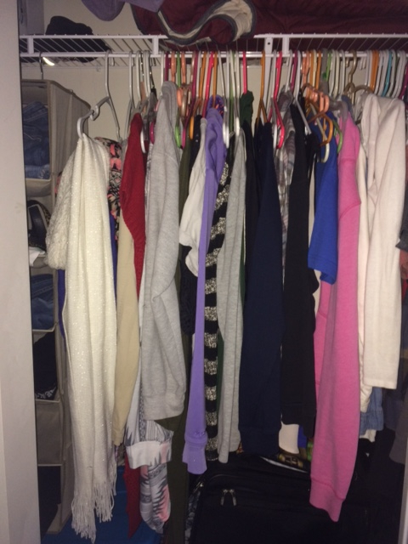

**Somewhat unorganized but everything is hung up “randomly”. No certain method of what should be hung together or what pants should be folded together in holders, etc. So many “hidden” things on shelves here. Another important thing to mention is this type of closet only slides open on one side. So it is already an inconvenience to see all the outfit options in her closet.**

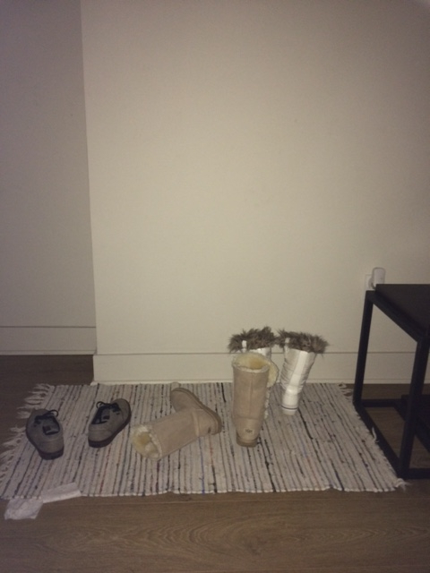

**(Shoe Mat)**

**What about shoe storage compared to closet space? How do people go about organizing all their shoes? Where do they put all of them in their dorms? Sometimes we often forget which shoes we even have that we have to store away because there is often not really any way or room available to visually representing every single pair of shoes we have. This is where we put all of our shoes in my apartment, yet I have about 10 other pairs of shoes hidden in my room somewhere.**

**(Andrea’s closet)**

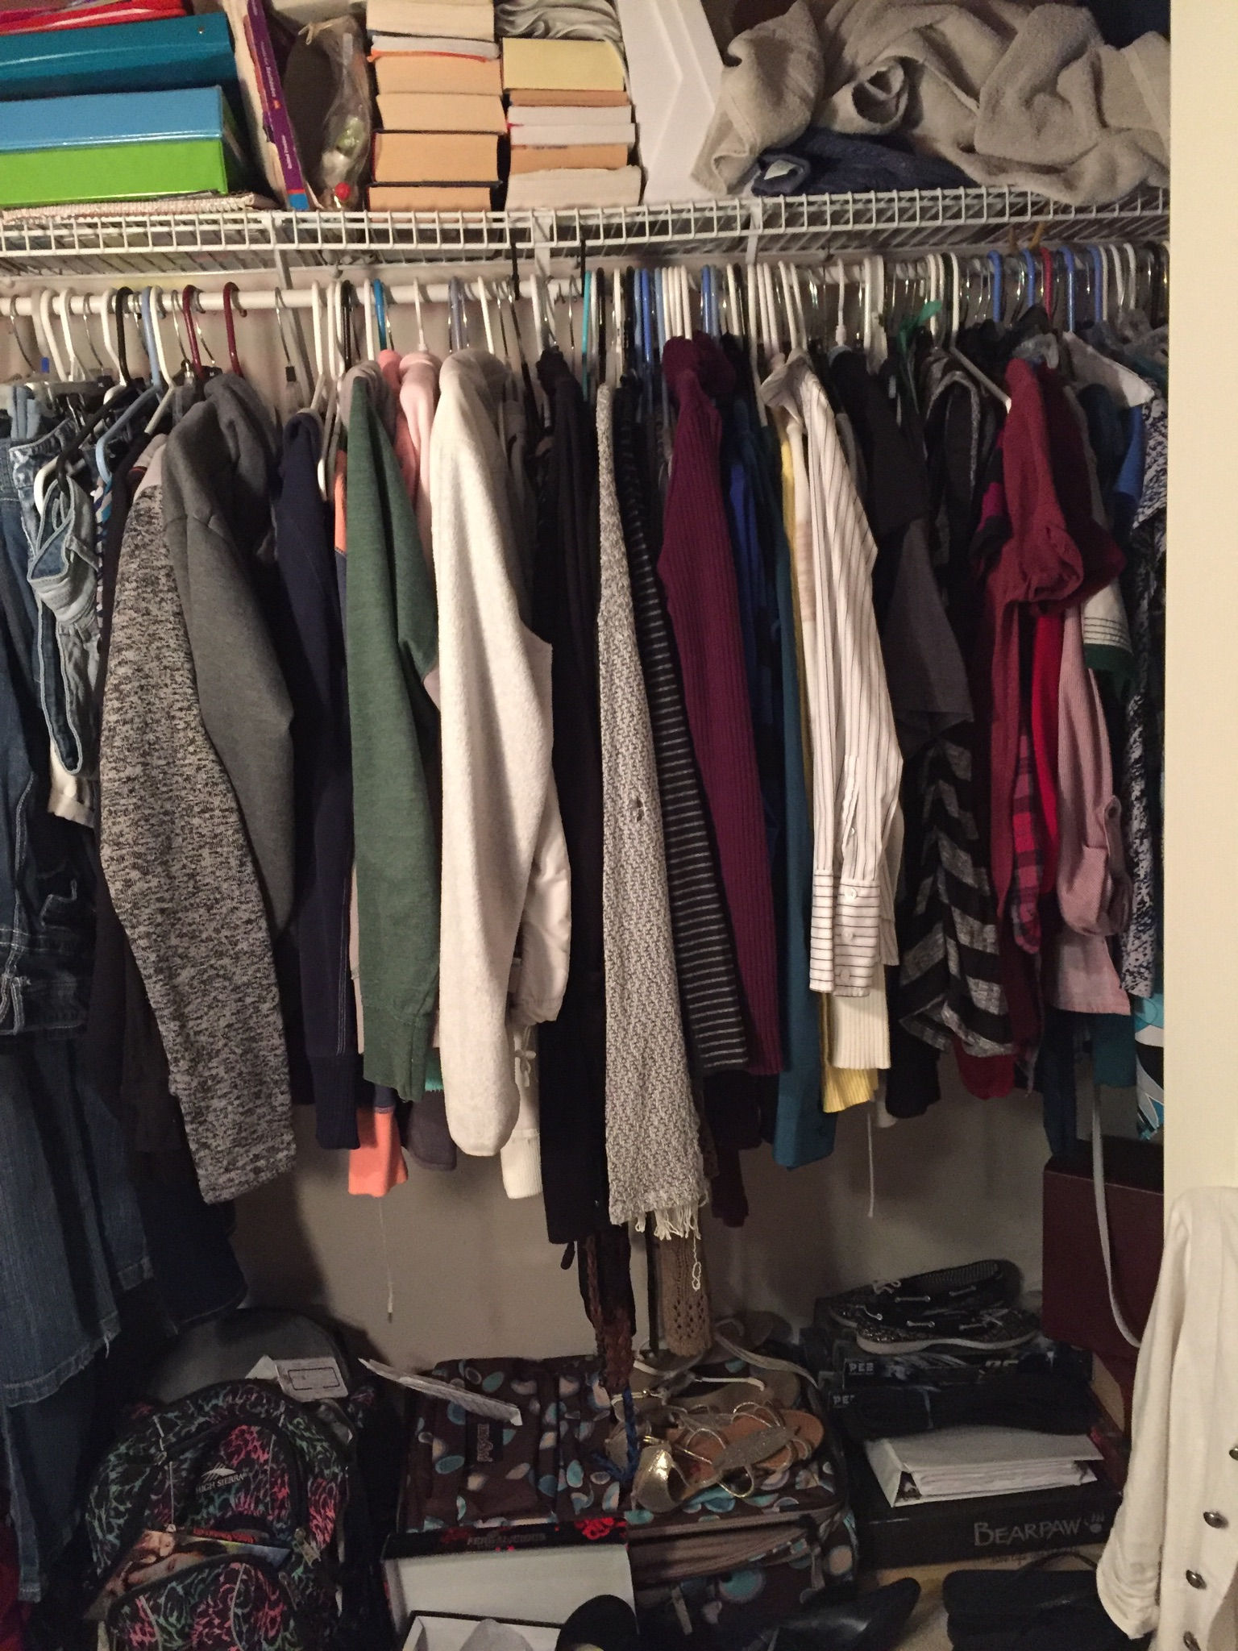

**Extremely organized. Even her non-clothing items are stacked up neatly on shelves or on the floor. All her clothes are organized by type of clothing item, then by color. So for example her long sleeve and short sleeve shirts are in different places. According to Andrea: “the strapless tops are far right, then tank tops, sleeveless, t-shirts, long sleeves, sweaters, hoodies, shorts, jeans, leggings, work pants, skirts, and lastly dresses. And every section is color codes within those groups.”**

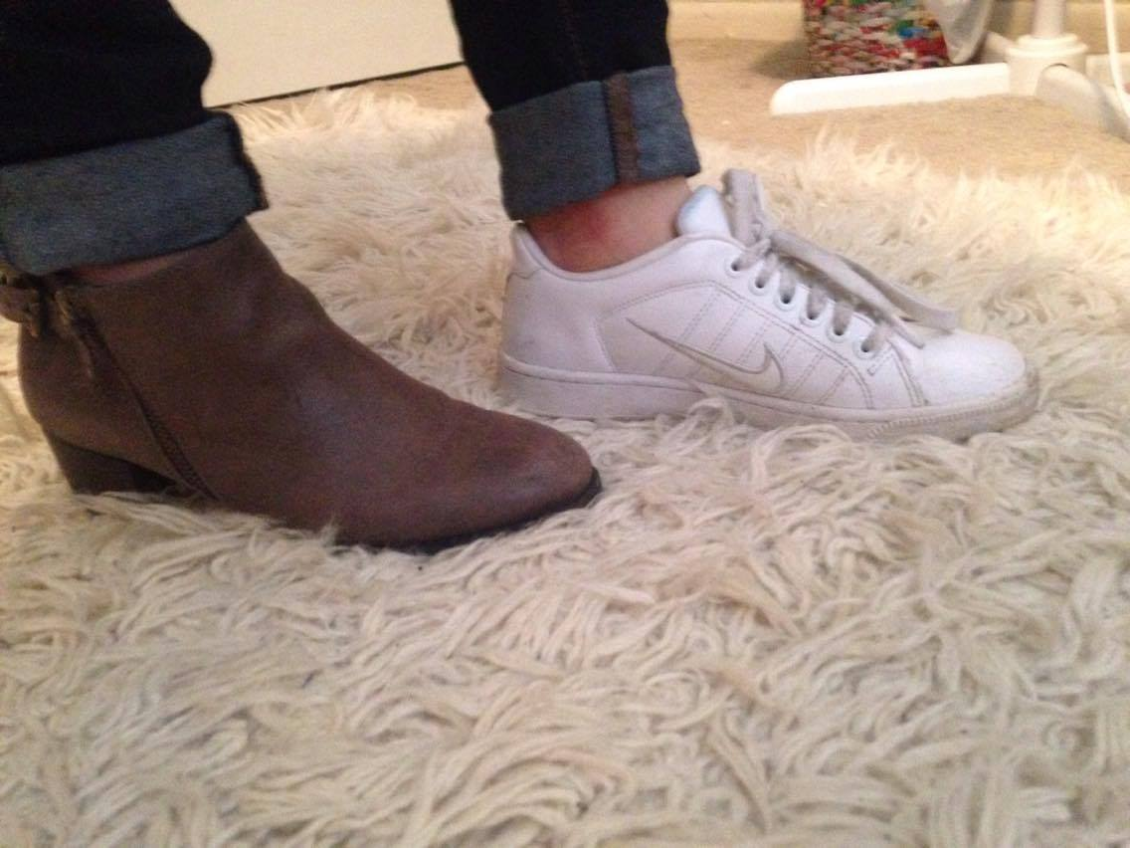

**What do each of these express about the person wearing the shoe? Is one more comfortable than the other? What type of situation would lead a person to chose one shoe over the other?**

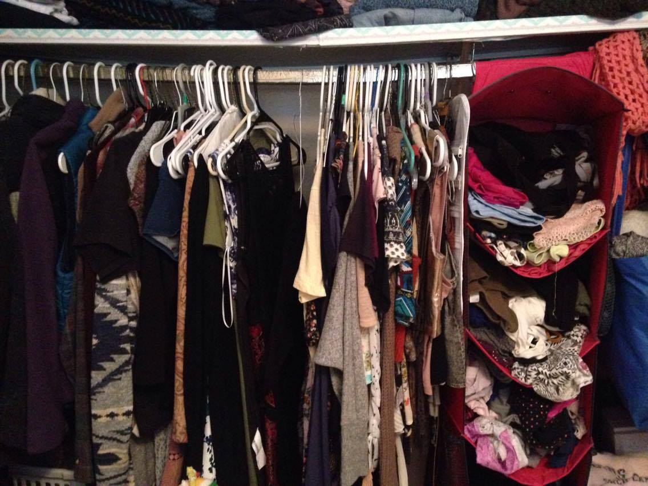

**(Interviewee #2’s closet) What a mess! No wonder people feel overwhelmed when looking for an outfit. What kind of styles are hidden in this mess? How many combinations are possible? There is much potential here!**

**Kristen’s Interview Transcripts (similarities she found between her two friends are highlighted):**

**Interviewee # 1: Andrea, 22**

**1.** **What thoughts come to mind when you think of what you're going to wear before you go out every day?**

During the work week, I want to make sure that I'm being as professional as possible. I don't like things that fit too tightly or show cleavage. I work at a bank, so it's very important that people aren't noticing me for what I'm wearing. But on the weekends, I wear whatever is comfortable and clean in my closet. I love baggy sweats and t-shirts!

**o How long does it typically take you to decide what you're going to wear? Explain why.**

I pick out all of my Monday-Friday outfits on Sunday afternoon. It takes me about an hour to pick them all out (jewelry included) and another half hour to steam and iron them. Saturday and Sunday, it takes me about a minute to figure out what I'm wearing and put it on.

**2.** **Walk me through any specific process you have (if any) when you go to shop for clothes in a store. If you have a certain method you use, can you describe what it is?**

I only go shopping when I need something, so I make it a point not to go into sections that don't contain what I'm looking for. That'll just make me spend my money on things that aren't necessary. The first thing I look for is style. If I don't like it on the rack, then I definitely won't like it on me. Then I look for size. And if I try it on and it fits, then I just have to make sure that it's flattering on me. The biggest thing is to be sure that you have all three things (style, right fit, visually appealing), because you won't wear it if one or more are missing.

**o Do you have an "imaginary" list in your head of some sort of what you plan to buy right when you walk into a store?**

I actually write what I need on my phone so I don't forget it.

**o Who do you bring with you when you go shopping and why?**

I bring my phone so I’ll have my list, my credit card so I can buy it, and maybe my mom so I can get her opinion.

**3.** **How often do you ask family, friends, and others for advice on outfits? What kinds of questions do you ask them?**

If it's work clothes, I ask my mom all the time! Anything else, I'm okay on my own. I always just make sure to ask if it looks good, if any part is unprofessional, and what I have in my closet that can go with it.

**(not included as interview question, just optional to answer and wanted their thoughts/insight) How do you feel about the idea of a "crowd sourcing" mobile app or a "virtual closet" mobile app that would enhance someone's physical experiences/choices/outfits in a store or at home before a night out?**

I love that idea!

**Interviewee # 2: Olivia, 22**

**1.** Thoughts about what I’m going to wear really depend on the day. If I’m going into work, it will only take me 5 minutes, due to my limited options o what I have to wear to work. If I’m going out to run errands, again maybe 5 minutes max. If I’m going out or have an event, it might take me a half hour, just because I’m very particular about my clothing selection at certain events.

-I think a lot about the location, the time of day, and the reason I’m going to said place. I’m very particular about my outfits, so I always take extra effort to plan what I’m going to wear.

**2. I** always put together an outfit in my mind before I go out shopping. I take a look in my closet first, and see if I can wear anything I already own. If there is something I like, but I don’t have something to complete the look, then I go out to find a piece to go with it.

**-**When I go shopping the only process for me will be thinking about the specific item that I need for the outfit or outfits I’m trying to plan. Typically I will go online first and pick through various options at different stores with items I like the best, and go to a mall that has all the stores to try everything on.

-I rarely bring anyone shopping with me if I’m on a mission for something specific. I do this because it’s more efficient for me, and I seldom take fashion tips.

**3.** Very rarely. I’m a very fashionable person in my eyes, and I say this with confidence because not only is it my job, but I also give friends and family fashion advice 99% of the time.

**4.** In terms of the app, there are many pros an cons to the idea of them. We use a program called CRM and St. John. In that program, we are able to keep track of virtually everything about our client. That being said, the program has an added feature that allows us to send “wardrobes” to clients. What that entails, a put together group of items we have in store, that is hand selected by the program clients have been drawn to from precious purchases, to their personal preferences that they have set up. It makes it easier for us to suggest items as well so we aren’t wasting their time showing them items that they aren’t going to want. Realistically, from a retail employee perspective mobile and or online shopping will be our main outlet for shopping in the future, allowing people to use features as listed above.

Joe Tang ALL INTERVIEWS DONE OVER SKYPE IN THEIR OWN DORM ROOMS  
Survey result:

Annie: First one available, usually doesn’t wear high fashion, chosen more for a control or a base of comparison for girl fashion.

Analysis: More function over style,

Q1. 3

Q2. 30 minutes

Q3. 1 hour 30 minutes

Q4. yes

Q5. how it would fit with my agenda for the day

Q6. yes

Q7. start with stuff I know I need to buy, and then usually go in order

Q8. A. 1-2 times a day

B. around 70%

C. if a friend, than 90%, otherwise not my style

Sarah: Close friend who friends can be slightly intimidated by her domineering but is just brutally honest with people.

Analysis: tends to be more relaxed but is stringent in critical view.

Q1. 5

Q2. 30 mins

Q3. 2 hours

Q4. yes

Q5. weather and comfort

Q6. no

Q7. Front to back

Q8. A. never

B. some parts

C. very honest

Vamsi: Realized I should probably seek a male opinion. Bit of a jokester with an underlying sincerity

Analysis: not a massive priority but has to have some logic to it.

Q1. 3

Q2. 5 minutes

Q3. 1 hour

Q4. no

Q5. do they match? Are they clothes?

Q6. no

Q7. just walk around until I find something I like  
Q8. A. almost never

B. sometimes i’ll try to change up my get up

C. not very honest

Ben: rather laid back and very busy person

Analysis: sacrifices some of his time to solicit feedback however won’t take the next step and develop it on his own

Q1. 3

Q2. 10 minutes

Q3. 30 minutes

Q4. yes

Q5. is it comfy

Q6. no

Q7. Start at the front and circle back around

Q8. A. I don't unless I'm indecisive about something

B. If it looks okay or not

C. Very honest

Ingrid: Very fashionable, people look to her for frequent advice and knows honestly most of MSU

Analysis: honestly I have no clue how she does it

Q1. 3

Q2. 15-20 minutes

Q3. 1 hour

Q4. no

Q5. weather, style, if it goes well with shoes

Q6. no

Q7. If I see any cute clothes from afar I gravitate towards there. Mostly spend more time in the clearance area

Q8. A. Very often

B. if it looks good on me, if it’s in style

C. Fairly honest

Mona: quieter, dresses not as flashy but with a subtle elegance. Also a dancer

Analysis: very much a reserved shopper, doesn’t risk or experiment much but everything has a certain amount of functionality and elegance to it.

Q1. 4

Q2. 1 hour

Q3. 3-4 hours

Q4. yes

Q5. weather, occasion, formality, comfort

Q6. no

Q7. no particular route, just see the whole store and take time on what catches my eye

Q8. A. only sometimes

B. usually only a little

C. If it’s really bad then I say so with alternate suggestions but usually I’m not that hon

**GRACE’S INTERVIEW TRANSCRIPTS (ROUGH NOTES)**

**Interviewee #1 (Female, 21, College Student, Active Lifestyle)**

-How do you pick out an outfit – bottoms 1st, dressy top (less conservatively?)

-Likes to have fun because has to dress conservative for work

-Accessories last

-Importance of style: comfort!!!! Style comes second

-Functionality is #1

-When clothing shopping: Always shops for a purpose. If you go to the store for leisure, never buys anything. So wait until you need the clothing item then purchase it.

-Ideal wardrobe? Yes. But too much money! (name brands like Nike, LULU, North Face) <- good quality, but costs too much

**money is a big theme. Incorporate coupon aspect??

**Interviewee #2 (Female, 23, Recent Graduate, Young Professional)**

1. Dresses for the vent <- assess the event.

-will I be walking a lot?

-is it cold or hot

2. always second guessing her outfit. Does it match?

-makes adjustments accordingly. “rotating process”

3. Style = a first impression // happy medium

-fashion is a reflection of personality <- is this a shallow statement?

4. What takes the most time when picking out an outfit?

-deciding what “look” you’re going for / is a appropriate for the event

5. When clothing shopping, do you know what you are looking for?

-Goes into store with intention, always ends up with something completely different

“Do you have an ideal wardrobe? What’s stopping you from obtaining hat wardrobe?”

-MONEY!! Have to be extremely attentive / active to find good deals

-must be creative in finding affordable ways to reflect one’s own style (if you lie name brand, find a “dupe”)

**Body image effects style! If it is not flattering and you don’t feel comfortable while wearing it, you can’t wear certain clothing, (ie. Crop tops or high waisted pants)

-may have an ideal style, but does it flatter your body type?

**THEMES:**

**1.** **People don’t have enough money to wear what they want to wear**

**2.** **Some people just don’t care that much about style**

**3.** **There is usually a time constraint when picking out what to wear. Personal style suffers because of this. (people aren’t wearing what they really wanted to wear because they ran out of time or simply couldn’t decide)**

**COMMON THEMES:**

1. **Instant gratification - in terms of the fact that we often seek our own opinion on outfits while out shopping and if it looks good to us we don’t want to wait around for opinions, too inconvenient i.e. especially while in a rush**
2. **Outfit items/choices are commonly hidden & limited the way our closets are built (most of the people we interviewed don’t have walk-in closets)**
3. **Time constraints - different times and days of the week often prevent people from picking out *exactly* what they needed or wanted to wear**
4. **Comfort over Style - some people prioritize what they wear on how comfortable they are in it rather than how it looks on them!**

**Interview Procedure**

We asked participants a total of 8 questions on various topics. First was “How important is style to you?” This was done first to establish a general knowledge on how the subject tastes were. The second questions was “how long does it take for you to get ready in the morning?” Having established their taste in fashion, the constraint of a busy morning is now applied to assess how quickly their decision making process. The third question was “What is the longest it's ever taken you to get ready to leave for anything?” Now we get a calculated response on an individual's choice when the time isn't a constraint. fourthly , “Do you have an Ideal wardrobe in mind?” Just to find out if they are active or passive in data collection on fashion. Fifthly, we posed “What decisions making process do you go through when picking out clothes?” to directly get their methods in choosing clothing. The sixth question was “ When walking into a store, do you know what you are going to buy beforehand?” to get a sense of their shopping habits and get their minds thinking about their buying mindsets. Naturally, the follow up question “How do you pick a route through the store?” directly get their processes from their minds. Last we asked them a 3 part question about their feedback. The first one posed was “How often do you ask people for feedback on what you are wearing?” to gauge their comfortability with getting feedback; next we wanted to find out their willingness to change with “What part or parts of the advice do you take?”; lastly we wanted to ask if they were honest with themselves with “How honest are you if you were asked for feedback.”

**Common Themes**

*Time constraint*

Most people do not have the luxury of unlimited time before they have to leave. This is the first barrier to be crossed when developing anything that influences their fashion choices. For more formal occasions usually people have something in mind before going.

*Money*

This limitation forces people's priorities in order. With a limited selection of clothing, getting more for less is very important to the point where it's okay to subvert choice in favor of affordability.

*Weather/comfort*

Grouping these two concepts together is a little bit of a stretch but people are always willing to sacrifice if it would come in danger with health.

*Occasion*

People have different priorities. Yet everyone has some knowledge to avoid social faux paus. As a society we acknowledge the fact that sometimes, the clothes make the man.

*Variability*

People with limitations need solutions to be more efficient. Naturally the theme of buying and wearing multipurpose clothing is an essential need.